India
Which raw materials are imported from which countries by the country that makes the product?
Silicon from China

Plastic from China

Iron from China

Aluminium from China and United States

Copper from Pakistan and Malaysia

Lead from United States

Zinc from Korea

Tin from China

Nickel from United States

Barium from Germany

My phone is really important to me, and I use it every day.

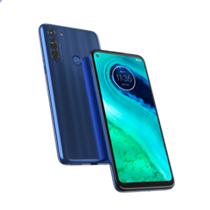
How does the international trade of my favourite product work?

Where is my favourite product made?
How is the product transported from the factory in India to countries? Who’s involved?
Why?
United States, China, Hong Kong, United Arab Amirates, Singapore, Germany, Belgium…

To which countries does India export its phones?

Who’s involved in making the product?
Factory employees
Pilots and truck drivers cooperate in exporting.

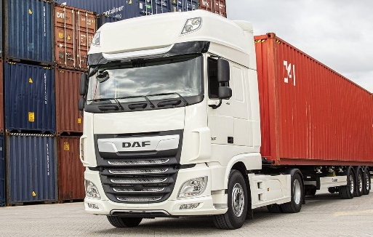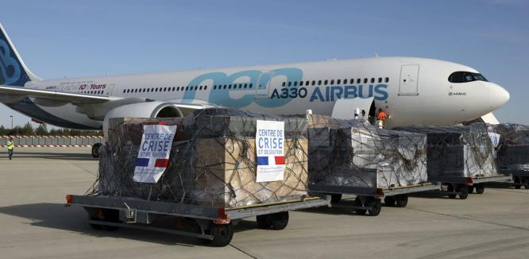
The phones are exported by plane from India to a country in the EU. This is most convenient because phones are small, and they do not weigh much. So, you can transport a large quantity in one go. The phones are transported from the airport to a company by truck.

Sources:
- https://nl.wikipedia.org/wiki/Motorola_Mobility
- https://nl.wikipedia.org/wiki/Motorola
- https://www.motorola.com/us/about
- https://www.motorola.com/us/about/corporate-responsibility-materials-disclosure
- https://technozive.com/motorola-belongs-to-which-country-is-motorola-a-chinese-company/
- https://www.statista.com/statistics/270454/top-10-materials-in-a-smartphone/
- https://tradingeconomics.com/india/imports-of-lead-articles-thereof
- https://trendeconomy.com/data/h2/India/7901#:~:text=Top%20trading%20partners%20(import%20of,2.3%25%20(7.8%20million%20US%24)
- https://wits.worldbank.org/CountryProfile/en/Country/IND/Year/LTST/TradeFlow/Import/Partner/by-country/Product/39-40_PlastiRub#:~:text=In%202019%2C%20the%20top%20partner,Singapore%2C%20United%20States%20and%20Japan.
- https://www.moneylife.in/article/india-becoming-dumping-ground-for-aluminum-scrap-especially-from-china-us/62769.html#:~:text=India%20has%20been%20caught%20in,to%20the%20levels%20in%20FY15.
- https://wits.worldbank.org/trade/comtrade/en/country/IND/year/2019/tradeflow/Imports/partner/ALL/product/281122#:~:text=India%20imported%20Silicon%20dioxide%20from,3%2C592.98K%20%2C%2013%2C240%2C500%20Kg).
- https://www.ibef.org/news/indias-copper-import-rises-26-in-q1-momentum-expected-to-continue-further-report#:~:text=Copper%20shipments%20from%20Pakistan%20and,reliance%20on%20India%20for%20imports.
- https://wits.worldbank.org/trade/comtrade/en/country/IND/year/2018/tradeflow/Imports/partner/ALL/product/750620#:~:text=India%20imported%20Nickel%3B%20plates%2C%20sheets,1%2C288.83K%20%2C%2043%2C157%20Kg).
- https://wits.worldbank.org/trade/comtrade/en/country/IND/year/2018/tradeflow/Imports/partner/ALL/product/800300#:~:text=India%20imported%20Tin%3B%20bars%2C%20rods,229.50K%20%2C%2010%2C200%20Kg).
- https://www.business-standard.com/article/economy-policy/india-s-iron-ore-imports-rise-157-during-april-december-2018-says-report-119031400702_1.html
- https://connect2india.com/global/import-Barium-to-india-from-germany

